For my Creative Computing module, I am utilizing a dataset that showcases the most streamed songs of 2024 that comes from [kaggle](https://www.kaggle.com/datasets). The goal is to analyze this data through various visualization techniques to better understand the trends and patterns in music streaming.

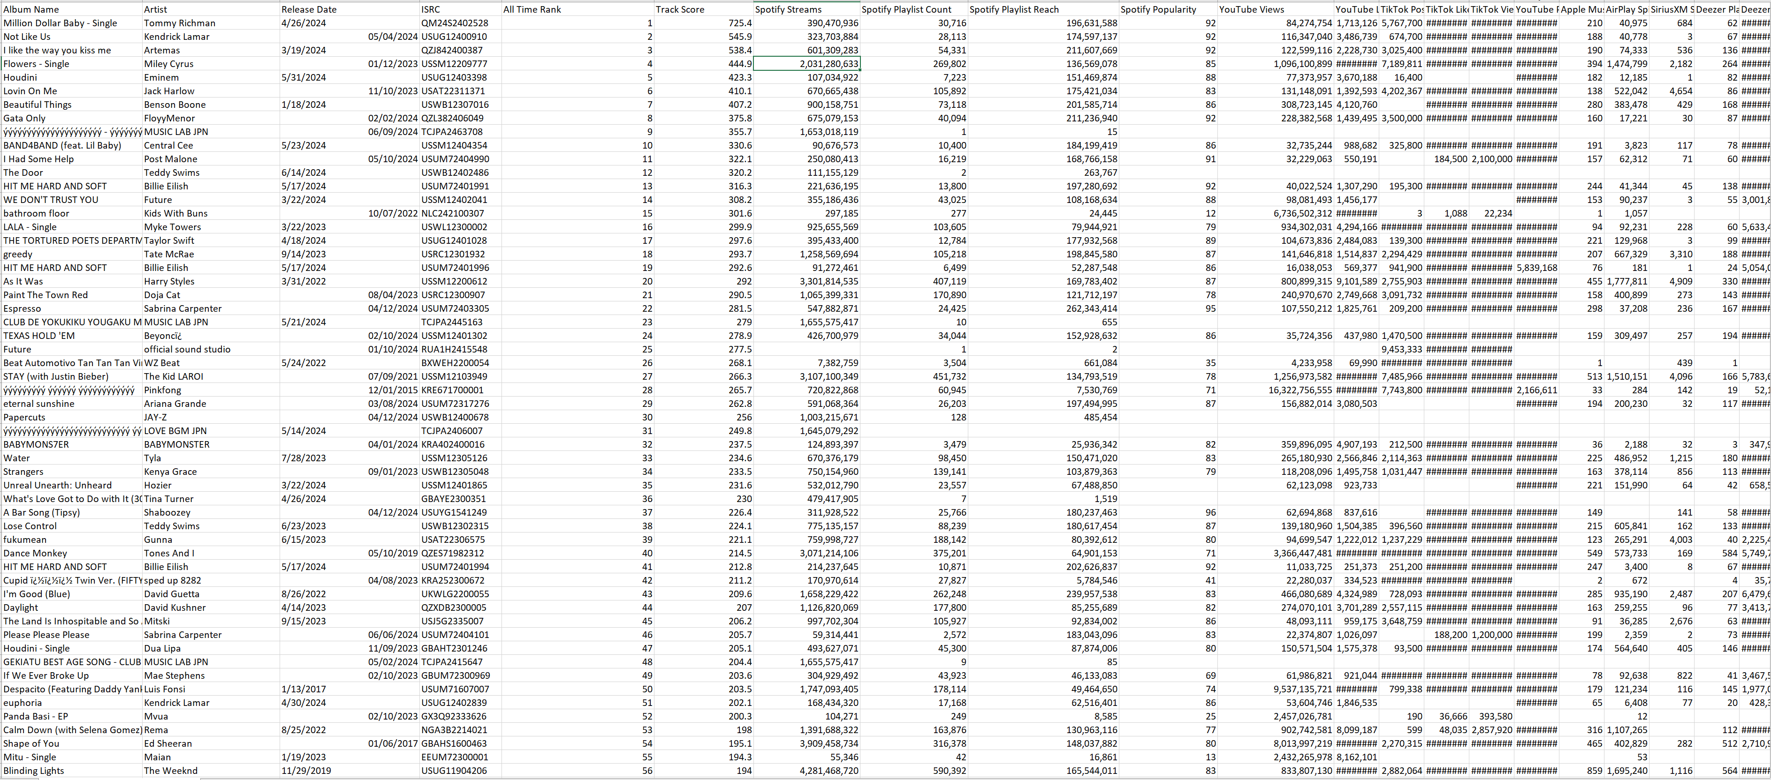

1. **Basic Bar Chart**: This type of chart will be used to display the top songs and their total number of streams. Each song will be represented by a bar, with the height or length of the bar indicating the number of streams. This will provide a clear, comparative visual of which songs are the most popular.
2. **Stacked Bar Chart**: To break down the data further, the stacked bar chart will be used. It allows for the comparison of multiple variables across the same category. For instance, it will show not only the total streams per song, but also the distribution of streams across different platforms (like Spotify, Apple Music, YouTube, etc.). This will help in understanding which platform is dominating for each song.
3. **Clustered Bar Chart**: A clustered bar chart will be used to compare groups of songs in different categories. For example, songs can be grouped by genre or artist, and the chart will display a separate bar for each category within each group. This will help analyze how different genres or artists are performing relative to each other in terms of streaming numbers.
4. **Nightingale (Polar) Bar Chart**: For a more visually engaging approach, the Nightingale bar chart (also known as a polar bar chart) will be used. This type of chart displays data in a circular format, with each bar representing a song and its streaming numbers. The length of each bar will vary based on the streaming volume, creating an interesting and aesthetically appealing radial design that offers an alternative view of the data.

These charts will be created using JavaScript, leveraging libraries such as D3.js to handle data manipulation and visualization. The goal of this project is to not only display the data effectively but also to gain insights into the music streaming landscape of 2024. By using a range of chart types, I can present different aspects of the data and offer a more comprehensive analysis in my Creative Computing module.

Top of Form

Bottom of Form